MANAGING DIABETIC RETINOPATHY

Managing diabetic retinopathy (DR) well requires the identification of those patients at risk of suffering sight loss due to diabetes before irreversible damages occur. We know that the appropriate use of laser treatment can prevent sight loss as a result of DR an therefore it is recommended that all diabetic patients are regularly examined under mydriasis by an ophthalmologist. However the problems are that not many follow this recommendation (between 10 and 36% of known people with diabetes have never had fundoscopy under mydriasis) and that there is a high proportion of the population without an ocular condition but who need to be screened, creating a work overload among ophthalmologists (about 70% of people with diabetes are estimated never to show signs of DR). Consequently the use of non-mydriatic cameras (NMC) and telemedicine has proved to be useful for this purpose (sensitivity > 80% and specificity > 90%) since it allows ophthalmologists to concentrate on available resources for handling patients with a treatable condition instead of using them to carry out screening. If the NMC method is used, the first imaging should be done within 5 years after the diagnosis in type 1 diabetes and from diagnosis in type 2 diabetes. Subsequently, screening will be carried out every 2-3 years among well controlled patients without visible DR. It will be done annually for patients showing no signs of DR but with high associated risk factors (poor metabolic control) and for those with mild non-proliferative DR (NPDR). It is currently being debated as to whether or not to maintain photographic screening at a higher frequency (every 3-6 months) for patients with moderate NPDR, or whether to send them to an ophthalmologist. Patients with severe NPDR, Proliferative DR (PDR) and Diabetic Macular Oedema (DMO) should all be under the care of ophthalmologists.
The aim of screening programs is hence to hand over patients with DR in need of a treatment to a competent ophthalmologist so that treatment can be given early enough to reduce the risk of sight loss and blindness due to DR and DMO.
If screening is carried out by an ophthalmologist, the establishment of the first examination under mydriasis will be:

- Type 1 diabetes: 3-5 years after the diagnosis of diabetes. If any sign of retinopathy appears, it is advisable to transfer the ocular management to hospital centres, due to the high risk of complications and the aggressiveness of these.
- Type 2 diabetes: the first examination will take place at diagnosis and then annual or biannual screenings are recommended if there are no associated risk factors, until the appearance of some degree of retinopathy. If retinopathy is detected, advice on how to manage it will be given according to the level of condition, the existence or non-existence of macular oedema, and/or the presence of secondary complications due to advanced retinopathy. Special attention should be given to patients with type 2 diabetes with early onset, specifically to those aged 30-40, due to their higher life expectancy and to inadequate metabolic control (hyperglycaemia, hypertension, dyslipidaemia and obesity), and to patients requiring insulin treatment, who can have similar complications to those patients with type 1 diabetes.

Monitoring:
To establish the frequency of follow-up checks, the level of retinopathy will need to be taken into account, as well as the presence or absence of maculopathy. In order to establish the number of visits, the higher sight risk will be the main criteria. For example, if a patient with moderate NPDR, who is recommended to have a control every six months, also presents an associated Clinically Significant Macular Oedema (CSMO), the number of check-ups will depend on the CSMO (i.e. every 3-4 months).

At every stage of DR, the endocrinological monitoring of the following is essential: glycaemia (glycated haemoglobin – HbA1c), high blood pressure (HBP), dyslipidaemia, anaemia, overweight and the renal status (microalbuminuria).

This can have two consequences: on one hand, if there is a considerate metabolic disorder, ocular monitoring will need to be more frequent; and on the other hand, the ophthalmologic treatment, of, for example, macular oedema, can be postponed until acceptable levels of glycaemia and/or blood pressure have been reached.

Likewise the patient will be recommended to stop smoking.

Referral of patients from general ophthalmologists to a retina specialist:
- Urgently (within the first month) if there is a inexplicable loss of VA (visual acuity) or suspicion of DMO or PDR (level IV evidence);
  - All cases of severe NPDR as they will need to be closely monitored to detect signs that might threaten the sight (level II evidence).
    - Patients with moderate NPDR with maculopathy (CSMO).

1 - WITHOUT APPARENT DIABETIC RETINOPATHY
- Ophthalmologist examination or NMC if there is a good metabolic control (HbA1c < 7%) and absence of associated risk factors (HBP, dyslipidaemia, etc.). In such cases biannual ophthalmic examination appears to be sufficient to detect on time both DMO and PDR. This will reduce the number of first visits to the ophthalmologist by 25%, which will considerably cut down health costs and prevent the patient with diabetes undergoing unnecessary examinations.
- Ophthalmologist examination or annual NMC if there are associated risk factors or the metabolic control is doubtful or deficient.

2 - WITH MILD NPDR
Ophthalmologist examination or annual NMC
Monitor more closely in the case of:
- high quantity of microaneurysms or if those threaten fovea,
- first examination of a patient poorly controlled,
- recent change from oral hypoglycaemic drugs to insulin,
- pregnant patients (a quarterly examination should be carried out and then every 6 months during the first year after the delivery).
At this stage it is also essential to inform and make the patient aware of the importance of metabolic control. According to the DCCT (Diabetes Control and Complications Trial) among patients with type 1 diabetes who maintain an average level of HbA1c of 7.2%, the effect of retinopathy is reduced by 76% and diabetic retinopathy by 54%.
The UKPDS (United Kingdom Prospective Diabetes Study) observed similar results among patients with type 2 diabetes. Also it demonstrated that strict control of blood pressure reduces DR by 34% and visual acuity deterioration by 47%.

Image 5
Image 5. Mild NPDR | 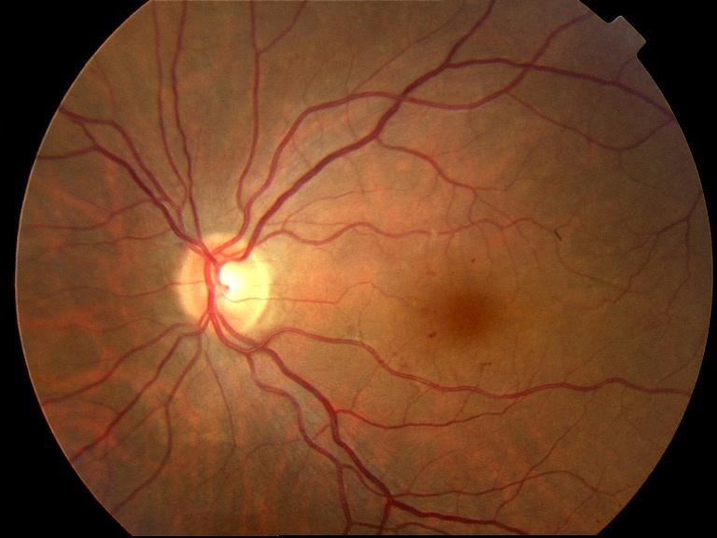

Liesenfeld B, Kohner E, Piehlmeier W, Kluthe S, Aldington S, et al. A telemedicine approach to the screening of diabetic retinopathy: digital fundus photography. Diabetes Care 2000; 23: 345-348.
Kollias AN, Ulbig MW. Diabetic retinopathy. Dtsch Arztebl Int 2010; 107: 75-84.
Hillier TA, Pedula KL. Complications in young adults with early onset type 2 diabetes-. Losing the relative protection of youth. Diabetes Care 2003; 26: 2999-3005.
Song SH, Hardisity. Early onset type 2 diabetes mellitus: a harbinger for complications in later years-clinical observation from a secundary care cohort. Q J Med 2009; 102: 799-806.
American Diabetes Assciation. Diabetes Care, volume 31, supplement 1, January 2008.
Olafsdóttir E, Stefánsson E. Biennial eye screening in patients with diabetes without retinopathy: 10-year experience. Br J Ophthalmol. 2007; 91:1599-601.
Diabetes Control and Complications Trial Research Group. Progression of retinopathy with intensive versus conventional treatment in the diabetes Control and Complications Trial. Ophthalmology. 1995; 102: 647-661
Diabetes Control and Complications Trial Epidemiology of diabetes Interventions and Complications Research Group. Retinopathy and Nephropathy in patients with tipo 1 diabetes four year after a trial of intensive therapy. N England J Med. 2003, 42: 381-389.
The relationship of glycemic exposure (HbA1c) to the risk of development and progression of retinopathy in the diabetes Control and Complications Trial. Diabetes 1995, 44: 968-983.
Diabetes Control and Complications Trial Research Group. The effect of intensive treatment of diabetes on development and progression of long termof long term complications in insulin-dependent diabetes mellitud. N England J Med. 1993. 329: 977-986.
UK Prospective Diabetes Study (UKPDS) Group. Intensive blood-glucose control with sulphonylureas or insulin compared with conventional treatment and risk of complications in patients with type 2 diabetes (UKPDS). Lancet. 1998; 352: 837-853.
UK Prospective Diabetes Study (UKPDS) Group. Tight blood pressure control and risk of macrovascular and microvascular complications in type 2 diabetes: UKPDS 38. BMJ. 1998; 317: 703-713.

